**Features**

A feature is like a particular service which is offered to the end user with a set of rules and based on role permission.

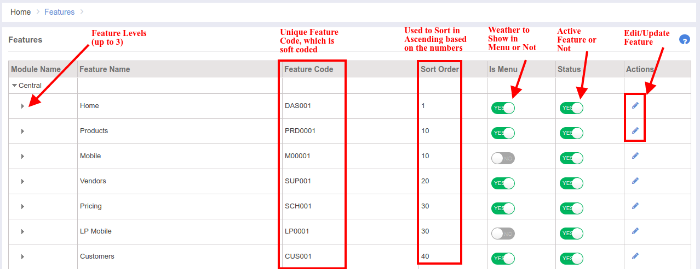

In our Ebutor System, we have 3 levels of features, and every feature has a unique code which is soft coded in almost all of your code modules.   
**Module Name:**

Module Name is the main parent of our entire application.

**Feature Name:**

Feature Name is a literal which is used to identify any feature.

**Feature Code:**  
 As said, Feature Code is unique varchar where it is decided and soft coded by the programmer.

**Sort Order:**

Sort Order option is used to arrange the features in the ui perspective. These are just numbers which are given to every feature to maintain on order in ascending manner.

**Is Menu:**

Is Menu option is used to check weather the feature (with name) should be show in the left menu of the web portal or not.

**Status:**  
 Status is used to represent weather the feature is active or not.

Feature Add/Edit Modal:  
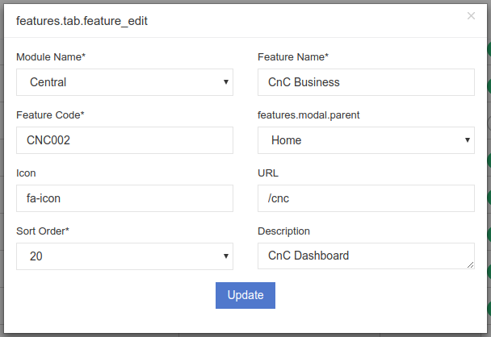  
Feature [Parent - Child] Relationship:  
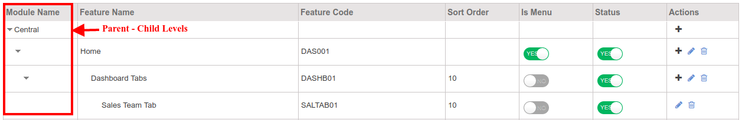  
  
Code Details:

Module Name: **Features**

URL: <https://portal.ebutor.com/rbac/features>

Features:

Add New Feature Permission [FRE002]

Edit Old Feature Permission [FRE003]

Delete Old Feature Permission [FRE004]

Code Flow:  
 To get all the features list, there is an method called **getdata()** in php laravel. This method populates the json data which is required for the features ui grid. This method generates json data using 3 foreach loops. It has 3 levels of steps.  
1st foreach loop is to populate the module names.

2nd foreach loop is to generate the parent features.

3rd foreach loop is to bring the child features of the parent.  
File Name: *Code/app/Modules/Features/Controllers/RbacController.php*